Modifying CAVI Model for ESP Analysis
Ross Wickham
Written for CWMS 3.1

Summary
This report documents the process used to modify a ResSim model for use with the Ensemble Streamflow Prediction (ESP) dataset developed by the Northwest River Forecast Center (NWRFC). The modification will allow Monte Carlo analyses to be quickly computed in forecast scenarios, providing a statistical likelihood for conditions of concern in the watershed. The major effort of modification involves remapping ESP inflows to CCP flow locations used in the ResSim model (Inflow Modifications section). Section layouts in this document are as follows:
Deployment – downloading tool, and establishing basic configuration
ESP Local Flow Computation and Configuration – creating required relationships used to establish local ESP time series
ResSim and CAVI Setup –create an ESP alternative in ResSim and the CAVI
Running ESP Simulation – run an ESP simulation once initial setup of CAVI for ESP is completed

Deployment
The following sections outline the steps, in sequence, needed to develop a CWMS ESP watershed from a CWMS watershed

Initial Tool Setup

Download ‘cwms_esp’ from GitHub
The cwms_esp tool is on GitHub at the following url:
https://github.com/RossWickham/cwms_esp
Download the tool as a zip file:
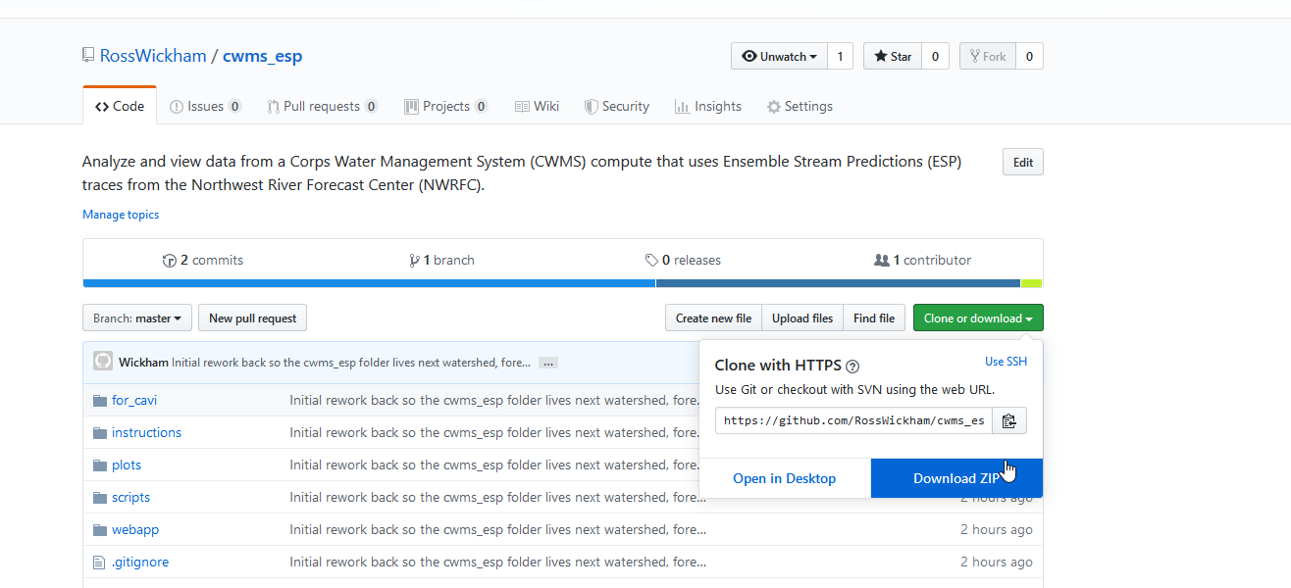
Unzip into the main CWMS directory containing the watershed, forecast, and database folders. Rename the folder to ‘cwms_esp’ if needed – there are scripts that require this naming convention.
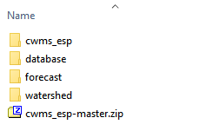
Alternatively, you can download the tool using the Git application if you’re familiar with it.

Configure R and Java
In order to run these scripts, you will need R (with necessary packages installed) and 64-bit Java. Talk to NWW personnel (Ross Wickham or Jon Roberts) if you need versions of R and/or Java. Within the cwms_esp tool’s main directory, there is an ‘r_java_esp_config.bat’ file that contains the information needed to configure the executable locations of R and Java.
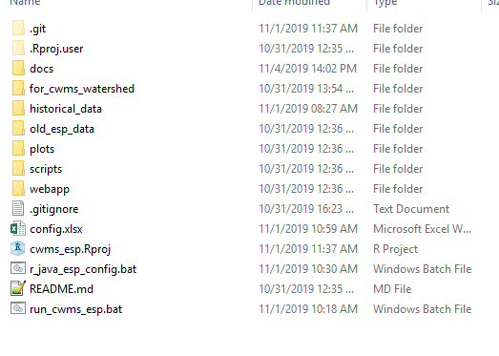
Right click the file and click ‘Edit’. The lines beginning with ‘set’ establish the ‘rExecutablePath’ and ‘baseJavaDir’ variables. Point these to the fully qualified paths for the Rscript.exe and base Java directories, respectively, as shown below. Quotes are needed for directory paths with spaces. Lines that begin with ‘rem’ are comment lines (remarks). Note that some ‘set’ lines are commented out from R installations used during testing:
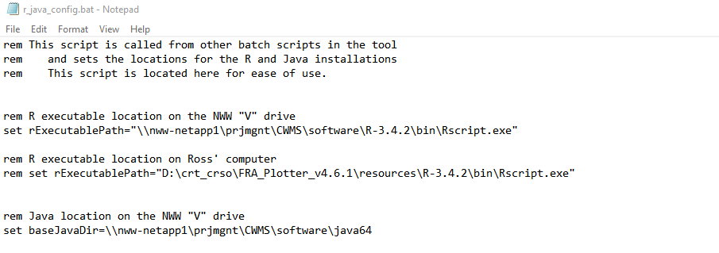
This script is called by the ‘run_cwms_esp.bat’ script and the ‘Download_ESP.bat’. It is advantageous to point to R and Java installations on a server that can be easily reached by other computers in the office to make the tool more portable.

Copy Scripts and Configurations into CWMS Watershed
Copy (be sure to copy-paste, not drag and drop) the ‘scripts’ and ‘shared’ folders from “../cwms_esp/for_cwms_watershed” folder into your CWMS watershed’s base directory:
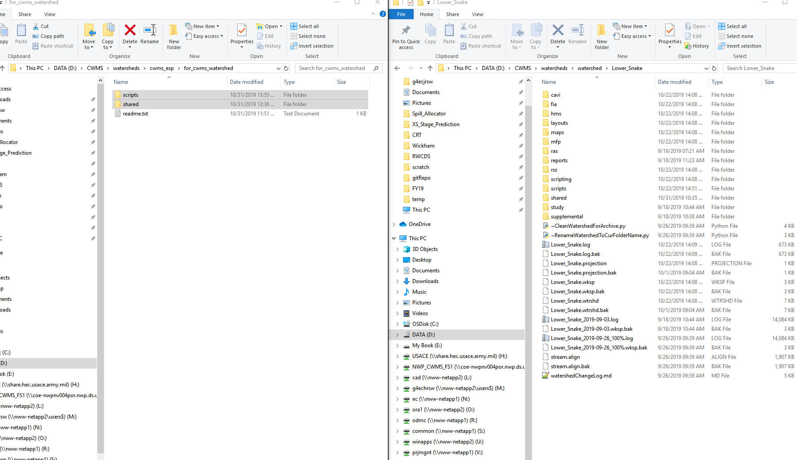

Your base CWMS directory should now have the following folder configuration. In this example, there are additional folders in the scripts and shared directory:
Figure 1. CWMS directory configured for ESP

ESP Download Setup
ESP traces are downloaded via the ‘scripts/Download_ESP.py’ script. This script can be added to the CAVI to run via click of a button. It can also be run manually via the ‘scripts/esp_download/Download_ESP.bat’ file. The script retrieves the RFC site IDs as defined in the ‘cwms_esp/config.xlsx’ ‘download_sites’ tab. Note: the script matches the entered NWRFC IDs against those in the ‘scripts/esp_download/rfc_esp_links.xlsxm’ Excel file’s ‘csvFileName’ column in the ‘natural’ tab using regular expressions. Instructions for finding the NWRFC IDs is shown below:
Figure 2. Finding NWRFC site IDs

ESP Local Flow Computation and Configuration
This section documents how the tables and configuration files used by the flow modifier (ESP local computation tool) are developed, and configured for use in the CAVI.

Overview
To compute local inflows in an ESP analysis, two primary elements are needed:
- Establish relationships for computing ESP locals
- Develop routing parameters for reaches
A local flow accounting is needed in the ESP analysis to accurately reproduce inflows that would otherwise be provided by HMS. The need for local flow accounting is demonstrated in the following examples:
Figure 3. Computing locals where CCP not associated with an ESP forecast location
The example shown above is from the Lower Snake CAVI model. Here, the local flow is needed for the Clearwater at Spalding CCP. HMS would typically provide this input in a standard CAVI compute, however there is currently no local flow data set for ESP traces. So, local flows are computed as a difference between all upstream contributions in the ESP traces and the total flow at the downstream CCP. In the example above, there is overlap between CCPs and ESP forecast locations at all but one of the CCPs: Lapwai Ck near Lapwai, shown with a shaded blue background. If flow contribution from this location can safely be ignored, then there is no need to attempt to account for inflow here. However, if flow at the location is important, it should be estimated. For the Lower Snake CAVI model, inflows at Lapwai were assumed to be correlated to flows at another nearby CCP. A relationship was established using USGS gage data that Lapwai Ck inflows are 14% of flows from the Potlatch below Little Potlatch CCP (see Appendix A for details). This relationship is provided to a flow modification tool that multiplies the Potlatch flows by 0.14, and creates new ESP traces associated with new DSS paths that can be linked to inflows at Lapwai Ck. The final equation used to compute local inflows at Spalding, accounting for Lapwai inflows, is provided in Figure 3.
Another issue that can arise is the situation shown below, where ResSim doesn’t overlay reaches modeled by the RFC. The ESP flows at Snake near Anatone account for inflows from the Grande Ronde at Troy (TRYO3), Salmon at Whitebird (WHBI1), and Imnaha at Imnaha (IMNO3) locations; none of which are in the ResSim model. Instead, the ResSim model was developed with the intent that flows would be provided by HMS routed down to the CCPs on the Snake River. The distance between the three ESP tributary locations and the mainstem river is far enough (up to 60 miles) that routing from the ESP locations to the Snake river can’t be ignored. So, the best option to compute local flows at Anatone is to lump inflows from TRYO3, IMNO3, and WHBI3 and compute local inflows at ANAW1 as a difference between ANAW1 and the routed flows from Hell’s Canyon (Figure 4).
Figure 4. Computing locals where ESP forecast locations don’t overlapped with ResSim CCPs
In addition to going through the exercise of establishing the relationships for computing local ESP inflows, the routing to parameters needs to be developed and configured for the flow modifier tool, as documented in the “Reach Routing, ModPuls Tables in DSS File” section.

Tool Basics
If ModPuls routing is being used, three files are necessary to the run the flow modification script. All of the files should be located in the “…/shared/flow_modifier” directory in the CWMS watershed:
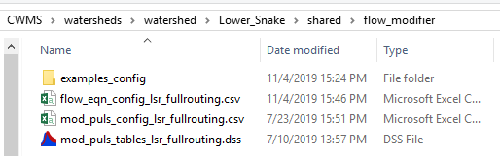
Figure 5. Example flow_modifier folder
The flow equation (“flow_eqn_config_*.csv”) file establishes the input DSS paths, output DSS paths, and the equations needed to compute boundary condition flows and local inflows. The Mod Puls configuration file (“mod_puls_config_*.csv”) links named DSS tables from the Mod Puls DSS (“mod_puls_tables_*.dss”) to a simplified table name, and the number of subreaches parameter needed for Mod Puls routing. In the example above, the “lsr_fullrouting” is unique to this watershed, and is needed in each file name to specify that these files define a set of routing equations and tables.

Local Flow Computation in CSV File
This section describes how the flow modifier creates boundary condition flows and local inflows used in the ESP simulations. The flow modifier computes after ESP data have been downloaded and prior to the CAVI compute. The

Table 1. Column descriptions in the flow_eqn_config csv file

Reach Routing, ModPuls Tables in DSS File
Because Mod Puls routing is the standard for the MMC, it is assumed that you will have ModPuls tables available. However, routing can easily be done with a lag method too, or ignored for a small enough reach.
The Mod Puls data can be created via RAS analysis, using the “Export to HEC-DSS” features. If you’re modifying an already completed CAVI model, it is likely that these tables already exist, but may need to be entered into DSS. By default, these tables are extracted from RAS in DSS format.
Example:
tblName | dssPath | nSubreaches
peck_to_pot_cf | //PECK TO POTLACH_CF/STORAGE-FLOW///NWW_CLEARWATER/ | 24

‘tblName’ defines the name to be used in the ‘flow_eqn_config’ function definition. E.g., the function string would be:
modifiedPulsRouting peck_to_pot_cf
You also need to define the DSS path and the number of subreaches. This process assumes the Muskingum X value is zero. The DSS path MUST have a C part of ‘STORAGE-FLOW’, or the computation will not work

Script Setup
The flow modifier tool is run from the “…/scripts/Flow_Modifier.py” script. You will need to set the ‘wshed’ string in this script to match that of the files that you have created. In the example below, the ‘wshed’ is set to “lsr_fullrouting” to indicate the watershed is Lower Snake River, and the routing parameters used are the full routing parameters as used in HMS/ResSim. The corresponding files in the “flow_modifier” directory are shown in Figure 5.
The other variable you’ll need to assign in the flow modifier script is the ‘espDssFileName’, which is defined in the ‘r_java_esp_config.bat’ script in the main cwms_esp directory.
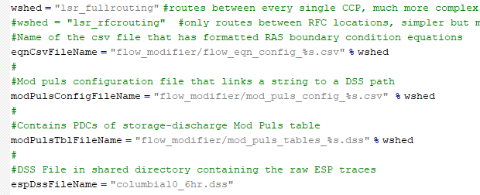
Figure 6. Example Flow_Modifier.py script configuration

Troubleshooting Local Flow Computation

Process will likely be iterative
If you’re not re-producing the full time period (e.g., ESP data are available Aug-Jan, but the local you’re computing only goes from Aug-Oct), then the routing is most likely going unstable. Check that there aren’t any very small reaches (<1 mile) that could be removed from the routing, and reasonably ignored.
Apply any multiplication factors after routing to avoid instabilities.

ResSim and CAVI Setup

ResSim ESP Alternative

Ensemble mode, monte carlo tab

Map inflows

Setup Dummy Import Module Rule Script
Set as release rule script of the reservoir that occurs first in the alphabet.
Alternatively, you can put the ‘sqlitejdbc-0.5.4.jar’ file into the CAVI installation’s jar folder (..\CWMS-vx.x.x\CAVI\jar). However, putting the jar file in the CWMS watershed, makes the watershed more portable and will have one less dependency when someone else attempts to run an ESP simulation.

Copy_ESP_to_Forecast_dss script
The CAVI extract is not able to easily transfer ESP data from the DSS file in the watershed’s shared directory (downloaded via ‘scripts/Download_ESP.py’) to the forecast.dss for the simulation. Thus, a script was developed to copy all ESP data from the ESP DSS to the forecast.dss. The script trasnfers all data within the forecast time window (requiring a forecast to be opened in the CAVI). This script can be added to the CAVI to run on the click of a button.

Running ESP Simulation

Looking at Results

Appendix A: Example Linear Regression Fitting of Inflows to CCPs Without ESP Data for Lower Snake Watershed
The inflows at the Tucannon, Lapwai, and Asotin CCPs in the Lower Snake CWMS watershed do not have corresponding ESP data from the RFC. To maintain a non-zero flow at these inflow locations, relationships were created between these locations and other nearby local inflows that do have RFC data. A brute force method was applied to fit single linear regression to each reasonable pairing of RFC forecast location. The following USGS stations were considered for independent variables in the regression fitting:
13351000 Palouse River at Hooper, WA
13341570 Potlatch below Little Potlatch Creek near Spalding, ID
13340000 Clearwater River at Orofino, ID
13317000 Salmon River at Whitebird
13292000 Imnaha River at Imnaha, OR
13342500 Clearwater River at Spalding, ID
13334300 Snake River at Anatone
Dependent variable data were:
13342450 Lapwai Creek near Lapwai, ID
13344500 Tucannon River near Starbuck, WA
13335050 Asotin Creek at Asotin, WA
USGS data were downloaded for the daily period of record at each site. Simple linear regression models were fit to each pairing of independent and dependent model, and the R² and root mean square error were tallied. Although the relationships do show a large amount of scatter, the flows of the Tucannon and Lapwai rivers are small with respect to the Clearwater and Snake Rivers. Thus, the risk associated with under-predicting the flows is small, and the scatter in the linear regression relationships is deemed acceptable. Results of the analysis are provided below, with selected linear regression fits highlighted.
Table 2. Results of linear regression fitting
Independent Variable (x) | Dependent Variable (y) | R² | Coefficient | RMSE (cfs)
palouse | lapwai | 0.69 | 0.11 | 95.02
potlatch | lapwai | 0.75 | 0.14 | 89.72
orofino | lapwai | 0.30 | 0.01 | 139.44
salmon | lapwai | 0.15 | 0.00 | 154.17
imnaha | lapwai | 0.30 | 0.12 | 136.26
spalding | lapwai | 0.39 | 0.01 | 131.72
anatone | lapwai | 0.36 | 0.00 | 132.96
palouse | tucannon | 0.68 | 0.15 | 139.82
potlatch | tucannon | 0.54 | 0.17 | 158.87
orofino | tucannon | 0.60 | 0.01 | 155.16
salmon | tucannon | 0.44 | 0.01 | 184.44
imnaha | tucannon | 0.56 | 0.23 | 164.62
spalding | tucannon | 0.69 | 0.01 | 136.32
anatone | tucannon | 0.67 | 0.00 | 140.85
palouse | asotin | 0.60 | 0.09 | 97.54
potlatch | asotin | 0.50 | 0.10 | 98.22
orofino | asotin | 0.60 | 0.01 | 98.05
salmon | asotin | 0.45 | 0.01 | 114.54
imnaha | asotin | 0.66 | 0.16 | 92.21
spalding | asotin | 0.64 | 0.01 | 92.37
anatone | asotin | 0.65 | 0.00 | 91.05

Tucannon
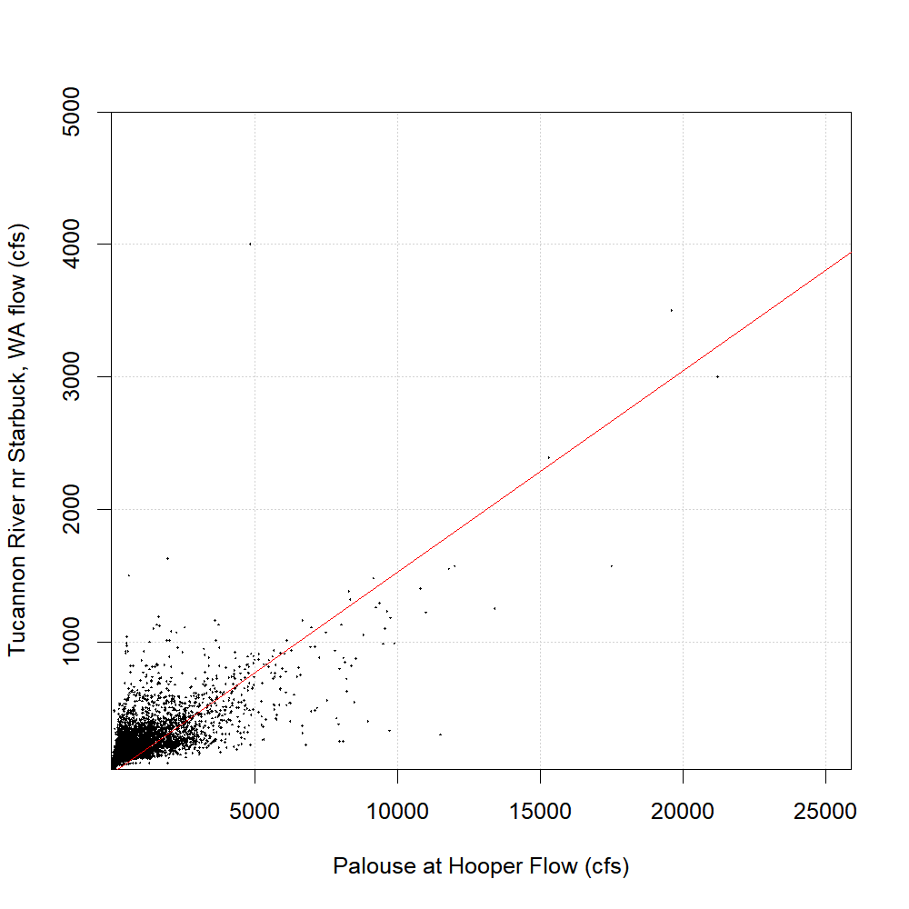
Selected Independent Variable: Palouse River at Hooper, WA (13351000)
Max Recorded Tucannon Flow = 5000 cfs
R² = 0.68
RMSE = 90 cfs
Eqn: Tucannon = 0.15*Palouse
Row in ‘flow_eqn_config_lsr_fullrouting.csv’ file:

Lapwai
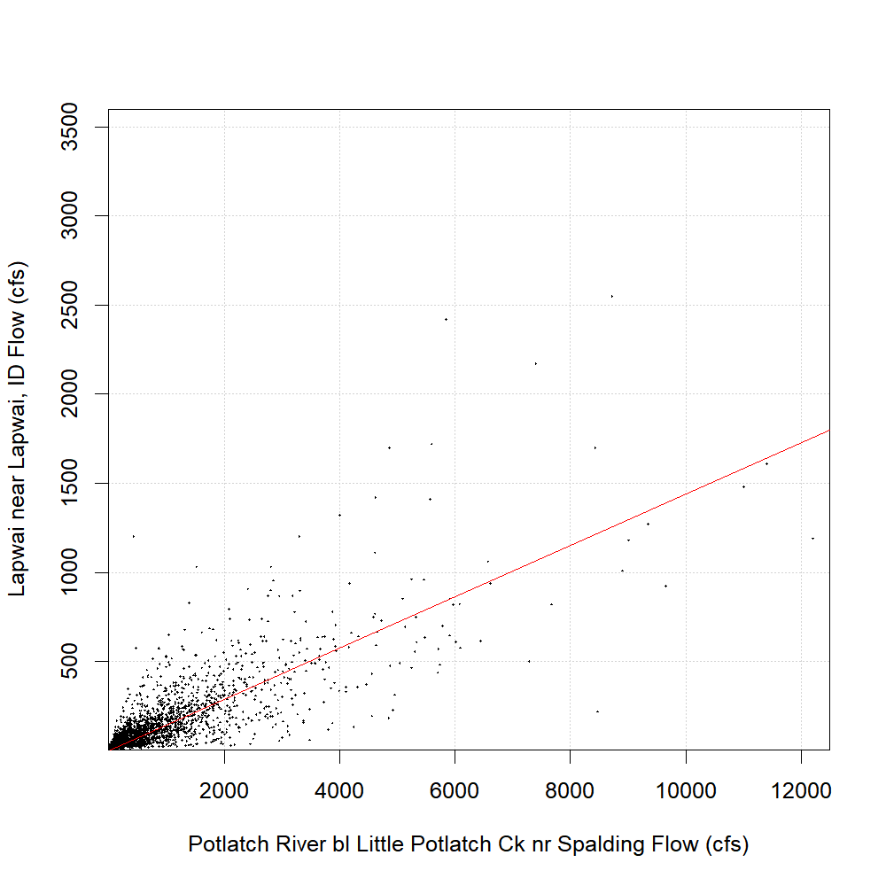
Selected Independent Variable = Potlatch below Little Potlatch Creek near Spalding, ID (13341570)
Max Recorded Lapwai Flow = 3600 cfs
R² = 0.75
RMSE = 140 cfs
Eqn: Lapwai = 0.14*Potlatch
Row in ‘flow_eqn_config_lsr_fullrouting.csv’ file:

Asotin
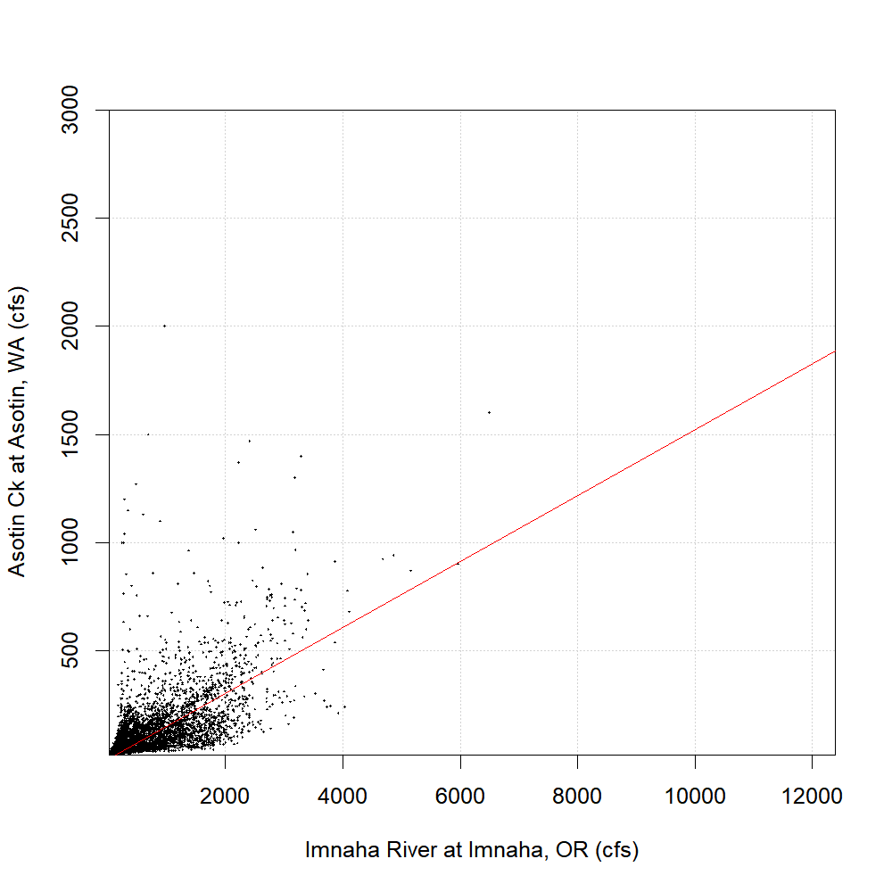
Selected Independent Variable = Imnaha River at Imnaha, OR
Max Recorded Lapwai Flow = 3000 cfs
R² = 0.66
RMSE = 92 cfs
Eqn: Asotin = 0.16*Imnaha
Row in ‘flow_eqn_config_lsr_fullrouting.csv’ file:

Appendix B: HecMath Functions

Lag
The lag function is defined in Ch. 8 of the DSSVue Manual (available in DSSVue install in ‘Users Manual’ folder), section 8.15.119:
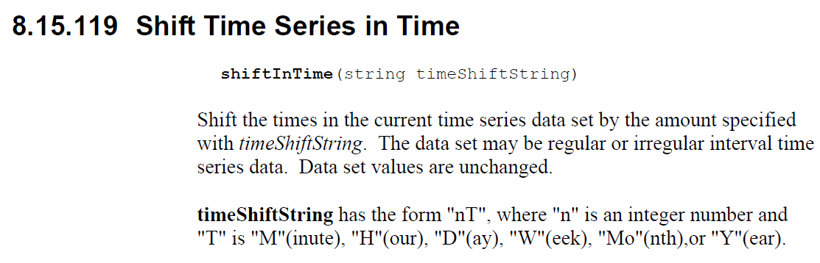
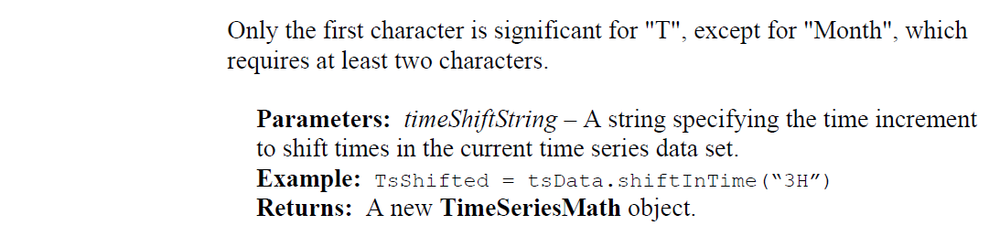
To apply lag to an ESP trace in the flow modifier, the column “var*_fns” associated with the time series to shift would include the following (if lagging by one hour):
shiftInTime str “1H”

Appendix C: Adding Scripts to CAVI
The CAVI allows users to add scripts to either be ran in the compute sequence, or by click of a button.

Running Script in Compute Sequence

